Mathematical Language at OPS

Purpose of this information: To build students’ understandings of mathematical words and concepts. To use the same language for mathematics across the school and at home.

4 processes  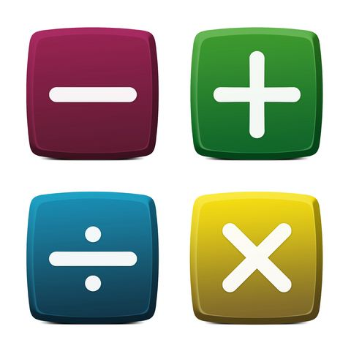 | Addition – Finding the total, or sum, by combining two or more numbers.  Subtraction – Taking one number away from another, for example if you have 5 apples and you subtract 2, you are left with 3.  Multiplication – The basic idea for multiplication is repeated addition e.g. 5X3=5+5+5 =15  But as well as multiplying by whole numbers, we can also multiply by fractions, decimals and more.  Division – Splitting into equal parts of groups. It is the result of “fair sharing”.
Algorithm | A well-defined set of instructions designed to perform a particular task or solve a type of problem, such as determining which of two fractions is larger, bisecting an angle, or calculating the mean of a set of numbers.
Automatic Recall | Knowing facts ‘off by heart’ for fast response.
Digits | There are 10 of them. 0,1,2,3,4,5,6,7,8 and 9.
Doubles/Near Doubles | Twice as many or nearly twice as many.
Extended (expanded) notation | Writing a number to show the value of each digit. It is shown as a sum of each digit multiplied by its matching place value (ones, tens, hundreds). For example: 293 = 2X100 + 9X10 + 3
Equals | Exactly the same amount or value. For example, 1+1=2 and1 dollar is equal to 100 cents.
Fractions | Represents the division of one whole number by another. They are also used to indicate a part of a whole number.
Integers | They are whole numbers such as (0, 1, 2, 3), but also include negative numbers (-1, -2, -3). They can be positive, negative or zero.
Natural numbers | Natural numbers are simply the numbers 1, 2, 3, 4 etc.
Number Lines | A line on which numbers (integers, whole numbers, natural numbers, fractions) are marked. These lines can be used to model mathematical thinking. For example: counting on, counting back, addition, subtraction, etc.
Numeral Identification | Reading and writing numbers.  Hindu-Arabic number system: 0123456789
Number word sequences and patterns | A list of numbers that follow a certain sequence or pattern. For example: 2, 4, 6, 8, 10, starts at 2 and jumps by 2 every time.
Numerals | The symbol for numbers, i.e. 4, 78, 632. They are all numerals!
Ordering Numbers | Numbers can be ordered in increasing (up/ascending) or decreasing (down/descending) in order of size (value). Can include whole numbers, fractions, decimals, etc.
Partitioning | Partitioning is a way of working out maths problems that involve large numbers by splitting them into smaller units so they’re easier to work with. For example 79+34=113 when partitioned is 70+30+9+4= 100+13=113
Place Value | The value of a digit in a number and its corresponding column, e.g. ones, tens, hundredths, etc.
Renaming | In everyday use, numbers often need to be renamed in a variety of ways. A number such as 68 can be viewed as 6 tens and 8 ones.
Structuring numbers | The crucial development of mentally adding and subtracting that is, not counting to get answers, like when you know 5 and 5 is 10.
Whole numbers | Whole numbers are the natural numbers along with zero: for example 0, 1, 2, 3, 4 etc.
Worded problems | When a mathematical problem is asked through a question using a real life experience.

